

Requirement & Design Specification

**Club Management System(SMS)**

**Version: 1.0**

**Group 1**

**HE191877 – Đặng Tuấn Minh**

**HE194251 – Cù Thị Huyền Trang**

**HE182034 – Nguyễn Đỗ Minh Quân**

# Table of content

**Table of content** **2**

**Record of Changes** **7**

**I. Overview** **10**

1. User Requirements 10

1.1 Actors 10

1.2 Use Cases 10

a. Diagram(s) 10

b. Descriptions 13

2. Overall Functionalities 15

2.1 Screens Flow 15

2.2 Screen Descriptions 20

2.3 Screen Authorization24

3. System High Level Design 24

3.1 Database Design 24

a. Database Schema 25

b. Table Descriptions

**II. Requirement Specifications** **27**

1. Common Functions 27

1.1 UC-1_SignUp 27

1.2 UC-2_Sign In 28

1.3UC-3_View all skills 28

**III. Design Specifications** **52**

**IV. Appendix** **92**

1. Assumptions & Dependencies 92

2. Limitations & Exclusions 92

3. Business Rules 92

# I. Overview

The **Club Management** project is a web application designed to manage clubs, members, events, and activities efficiently. Built with **Servlet, JSP, JDBC**, and **SQL Server**, it follows the **MVC architecture** with role-based access control. The frontend uses **HTML5, CSS3, Bootstrap5, and JavaScript** for a responsive interface. Key features include **club and member management, event tracking, task assignments, notifications, and reports**, optimizing club operations and enhancing user experience.

## 1. User Requirements

### 1.1 Actors

|  |  |  |
| --- | --- | --- |
| **STT** | **Actor** | **Description** |
| 1 | Admin | Have full system management, including all CRUD functionality for user, Club, Events ,Member, and order details. |
| 2 | Chairman | Oversees club operations, approves events, manages members, and assigns roles. |
| 3 | ViceChairman | Assists the Chairman in managing the club, reviewing reports, and coordinating activities |
| 4 | Member | Participates in club activities, events, and can submit feedback or requests. |
| 5 | TeamLeader | Leads a specific team within the club, assigns tasks, and manages team performance. |

### 1.2 Use Cases

#### a. Diagram(s)

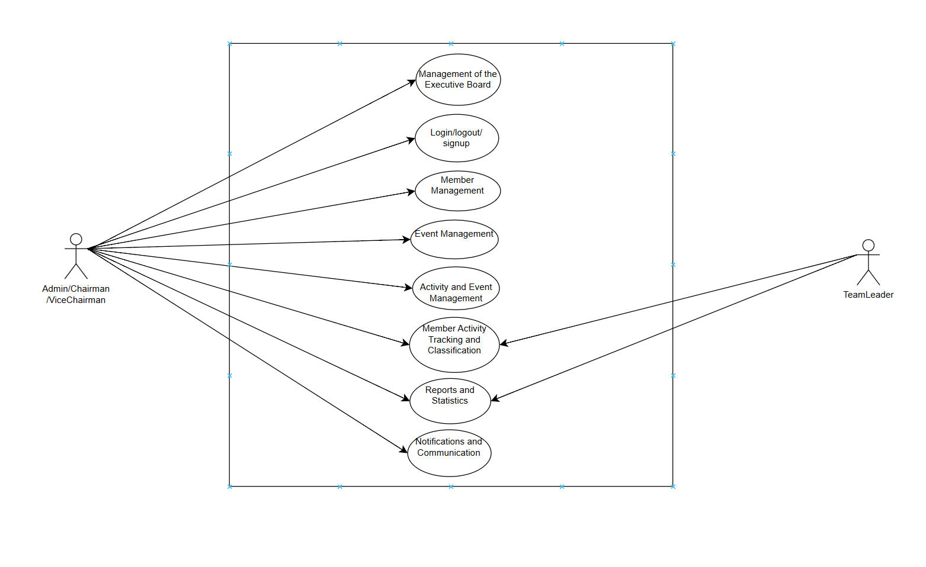

#### b. Descriptions

|  |  |  |  |
| --- | --- | --- | --- |
| **ID** | **Feature** | **Use Case** | **Use Case Description** |
| 01 | Admin/Chairman/ViceChairman | Management of the Executive Board | Configure the club's executive board  Assign detailed permissions for each role within the executive board. |
| 02 | Member Management | Add, remove, and update member information.  Track each member's activity history.  Search for members by name, student ID, or role. |
| 03 | Event Management | Add, edit, delete, view event information. |
| 04 | Activity and Event Management | Manage regular activities and special events of the club.  Track event status (completed, ongoing, canceled).  Assign responsibilities to executive board members and club members. |
| 05 |  | Notifications and Communication | Add, edit, view notification information. |
| 07 | TeamLeader | Member Activity Tracking and Classification | Track member participation per semester (three semesters per year). |
| 08 | Reports and Statistics | Add, edit, view report information. |

## 2. Overall Functionalities

### c2.1 Screens Flow

## 

|  |  |  |  |
| --- | --- | --- | --- |
| **#** | **Feature** | **Screen** | **Description** |
| 1 | HomePage | Home | This page will show the information in this website |
| 2 | LoginUser | Login | This page will allow you to enter email and password |
| 3 | SignupUser | Signup | If user haven’t had account before, they will signup |
| 4 | Management of the Executive Board(Admin/Chairman) | Management of the Executive | Admin or chairman can assign detailed permissions for each role within the executive board. |
| 5 | Member Management  (Admin/Chairman) | Member Management | Admin and chairman can add, remove, and update member information. Track each member's activity history. Search for members by name, student ID, or role. |
| 6 | Activity and Event Management | Activity and Event Management | Chairman and Vicechairman can manage regular activities and special events of the club. Track event status (completed, ongoing, canceled). Assign responsibilities to executive board members and club members. |
| 7 | Member Activity Tracking and Classification | Member Activity Tracking and Classification | All members will follow the activity of each other |
| 8 | Reports and Statistics(TeamLeader) | Reports and Statistics | Leader can create , edit , follow information of club |
| 9 | Reports and Statistics(Others) | Reports and Statistics | They can watch and follow information through the years |
| 10 | Notifications and Communication(Chairman) | Notifications | Chairman send announcements from the executive board to all members via email or the application |

### 2.2 Screen Descriptions

### 2.3 Screen Authorization

|  |  |  |  |  |  |  |
| --- | --- | --- | --- | --- | --- | --- |
| **#** | **Screen** | **Admin** | **Chairman** | **Vicechairman** | **Leader** | **Member** |
| 1 | Log in | X | X | X | X | X |
| 2 | Home | X | X | X | X | x |
| 3 | Management of the Executive Board | X | X | X |  |  |
| 4 | Member Management | X | X | X |  |  |
| 5 | Event Management | X | X | X |  |  |
| 6 | Activity and Event Management | X | x | X |  |  |
| 7 | Member Activity Tracking and Classification | X | X | X | X | x |
| 8 | Reports and Statistics | X | x | x | X |  |
| 9 | Notifications and Communication | x | x | x |  |  |

### System High Level Design

### 3.1 Database Design

#### Database Schema

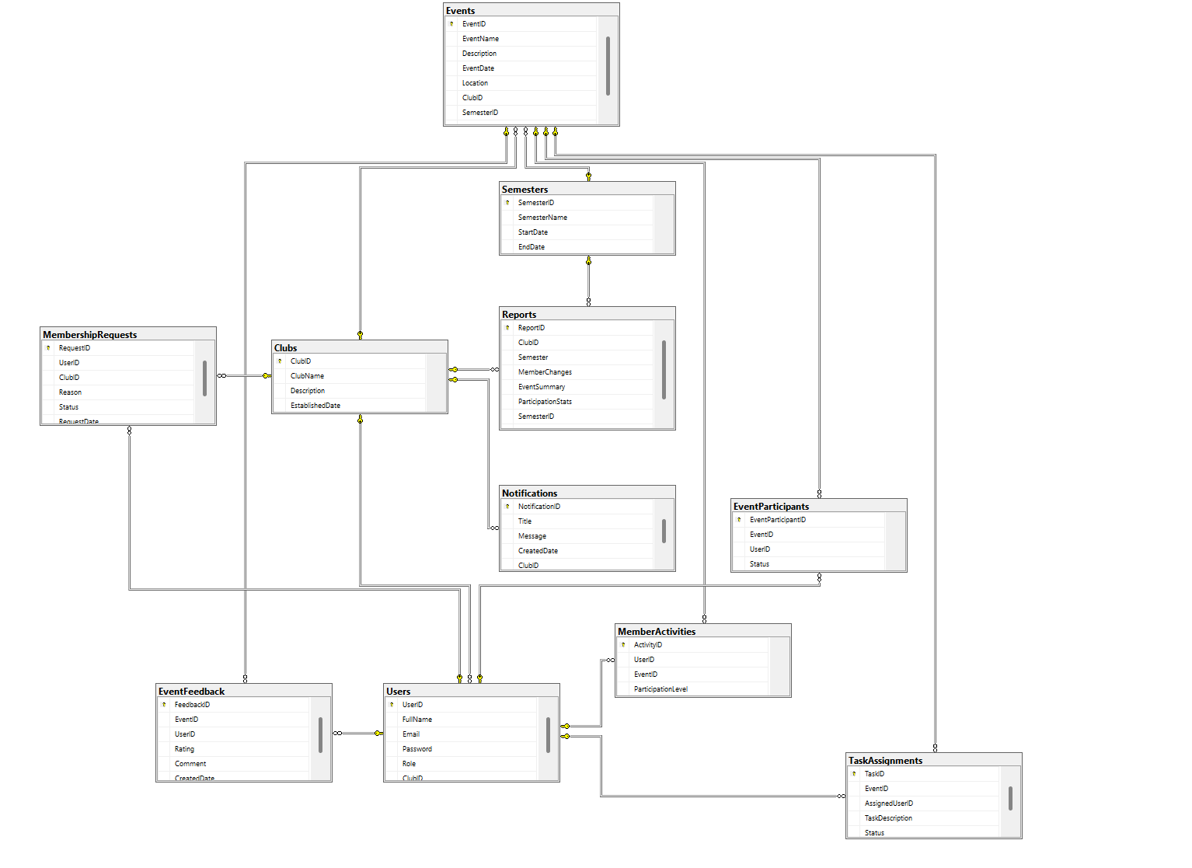

#### b. Table Descriptions

#### b. Table Descriptions

| **No** | **Table** | **Description** |
| --- | --- | --- |
| 01 | Users | - Manages user accounts with fields for UserID,FullName, Email, Password, Role, ClubID.  - Primary keys: UserID |
| 02 | Club | - Stores club information with fields for ClubID, ClubName, Description , EsatblishedDate  - Primary keys: ClubID |
| 03 | Events | - Manages Events with fields for EventID, EventName, Description,EventDate, Location,ClubID,SemesterID,Status  - Primary keys: for OrderID |
| 04 | Reports | - Stores report with fields for ReportID, ClubID, Semester, MemberChanges, EventSummary, ParticipationStatus,SemesterID  - Primary keys: ReportID |
| 05 | Notifications | - Stores notification with field for NotificationID,Title,Message, CretedDate,ClubIS  - Primary keys: NotificationID |
| 06 | MembershipRequests | - user request processing join club with fieds for RequestID,UserID,ClubID,Reason,Status,RequestDate  - Foreign keys: RequestID |
| 07 | Semesters | Store semester information with fields for SemesterID,SemesterName,StartDate,EndDate  - Primary keys: SemesterID |
| 08 | EventParticipants | Manage member join event information with fiels for EventParticipantID,EventID,UserID,Status  - Primary keys: ProductID |
| 9 | EventFeedback | -Store information feedback about event with field for: FeedBackID,EventID,UserID,Rating,Comment,CreatedDate  -Primary keys: FeedBackID |
| 10 | TaskAssigments | - task assignment information storage with fieds for TaskID,EventID,AssignedUserID,TaskDeciption,Status  -Primary keys: TaskID |
| 11 | MemberActivites | - activity level assessment with field for:ActivityID,UserID,EventID,ParticipationLevel  -Primary keys: ActivityID |
|  |  |  |
|  |  |  |
|  |  |  |
|  |  |  |
|  |  |  |
|  |  |  |

# II. Requirement Specifications (OPTIONAL)

## 1. Common Functions

### 1.1 UC1_ Login

**Functional Description Template**

|  |  |  |  |
| --- | --- | --- | --- |
| ID and Name: | UC-1_ User Login | | |
| Created By: | HE191877  Đặng Tuấn Minh | Date Created: |  |
| Primary Actor: | User | Secondary Actors: |  |
| Description: | This use case describes the authentication process for users by verifying their email and password. | | |
| Trigger: | User attempts to log in. | | |
| Preconditions: | PRE-1: User has an existing account. | | |
| Postconditions: | * POST-1: User is logged into the system and can access authorized functionalities. | | |
| Normal Flow: | 1. User enters an email and password. 2. System verifies credentials. 3. If valid, user is logged in; otherwise, an error message is displayed | | |
| Alternative Flows: | N/A | | |
| Exceptions: | EX-1: Database connection error. | | |
| Priority: | High | | |
| Frequency of Use: | Frequently used by all users. | | |
| Business Rules: | N/A | | |
| Other Information: | N/A | | |
| Assumptions: | N/A | | |

### 1.2 UC2_Logout

a. Functional Description

|  |  |  |  |
| --- | --- | --- | --- |
| ID and Name: | UC-2_ Logout | | |
| Created By: | HE191877  Đặng Tuấn Minh | Date Created: |  |
| Primary Actor: | User | Secondary Actors: | None |
| Description: | When user logout, data about user in web will delete and come back to Login. | | |
| Trigger: | User attempts to log out. | | |
| Preconditions: | Data user in web is existed | | |
| Postconditions: | N/A | | |
| Normal Flow: | When they click the button Logout. They will back to Login page. | | |
| Alternative Flows: | N/A | | |
| Exceptions: | N/A | | |
| Priority: | High | | |
| Frequency of Use: | Usually | | |
| Other Information: | N/A | | |
| Assumptions: | N/A | | |

### 1.3 UC3_SignUp

|  |  |  |  |
| --- | --- | --- | --- |
| ID and Name: | UC3_Signup | | |
| Created By: | HE191877  Đặng Tuấn Minh | Date Created: |  |
| Primary Actor: | User | Secondary Actors: | None |
| Description: | If user haven’t had account before, they will click signup. In signup page, they will enter full name, email and password. | | |
| Trigger: | Admin clicks on the "SignUp" button in the topnav. | | |
| Preconditions: | N/A | | |
| Postconditions: | Information must not exist in database. | | |
| Normal Flow: | If user haven’t had account before, they will click signup. In signup page, they will enter full name, email and password. | | |
| Alternative Flows: | N/A | | |
| Exceptions: | N/A | | |
| Priority: | High | | |
| Frequency of Use: | Frequent | | |
| Other Information: | N/A | | |
| Assumptions: | N/A | | |

### 1.4 UC4_SignUpCLB

a. Functional Description

|  |  |  |  |
| --- | --- | --- | --- |
| ID and Name: | SignUpCLB | | |
| Created By: | HE191877  Đăng Tuấn Minh | Date Created: |  |
| Primary Actor: | User | Secondary Actors: | none |
| Description: | If users haven’t joined any clubs, they can join and wait the chairman assign them | | |
| Trigger: | Admin clicks on the "Tham gia" button in the Home Page. | | |
| Preconditions: | User must in website with their account  Users haven’t join any clubs | | |
| Postconditions: | User add in MemberRequest and wait the assign from chairman | | |
| Normal Flow: | 1. Admin clicks on the " Tham gia " button in HomePage. 2. The system displays form signup club include username, email and reason. 3. After finishing, user can add a new request by clicking “register". 4. Temporarily, they don’t have club | | |
| Alternative Flows: | N/A | | |
| Exceptions: | If web check user have send request before and pend the assign. Web will send error that “You have send request befor”. | | |
| Priority: | High | | |
| Frequency of Use: | Usually | | |
| Other Information: | N/A | | |
| Assumptions: | N/A | | |

### 1.5 UC5_AssignRequest

a. Functional Description

|  |  |  |  |
| --- | --- | --- | --- |
| ID and Name: | AssignRequest | | |
| Created By: | HE191877  Đặng Tuấn Minh | Date Created: |  |
| Primary Actor: | Chairman/Admin | Secondary Actors: | none |
| Description: | As an admin, I will assign user to my clubs with suitable reason. When I assign user, I can add them to my club | | |
| Trigger: | Admin clicks on the "Chap nhan" or “Tu Choi” button in Phe Duyet | | |
| Preconditions: | Admin must be logged in as Chairman. | | |
| Postconditions: | Userinformation is added, updated, viewed, or deleted when accept. | | |
| Normal Flow: | * Chairman clicks on the "Phe Duyet" button. * Web will display the list of request from the user * With user, they just see the status and cant edit * Chairman can edit the request. * If chairman click “Chap nhan”, user can add to the club. Contrarily, user will be deleted from request and can send request again. | | |
| Alternative Flows: | N/A | | |
| Exceptions: | N/A | | |
| Priority: | High | | |
| Frequency of Use: | Usually | | |
| Other Information: | N/A | | |
| Assumptions: | N/A | | |

### 1.6 UC6_ Member Activity Tracking and Classification

|  |  |  |  |
| --- | --- | --- | --- |
| ID and Name: | Member Activity Tracking and Classification | | |
| Created By: | HE191877  Đặng Tuấn Minh | Date Created: |  |
| Primary Actor: | User | Secondary Actors: | none |
| Description: | User can see their activities in club through the year. And know their participation level in that year | | |
| Trigger: | Admin clicks on the "Đánh giá" button in the homepage. | | |
| Preconditions: | User must login their account to see it | | |
| Postconditions: | Watch their activities in club through the year | | |
| Normal Flow: | * After login the website, they will clicks on ”Đánh giá” in home page. * After clicking, web display the list of member in their club about the participation level. * It includes fullname, id, year, event attended, total event of year. * They can choose the year to see the data of that year by dropdown year in web | | |
| Alternative Flows: | They can click “view” button to see the level they achieve.  It classifies members based on participation level:   * **Active:** Attended more than 80% of events. * **Normal:** Attended between 50% and 80% of events. * **Inactive:** Attended less than 50% of events. | | |
| Exceptions: | If some member doesn’t join any event in that year, web set default “chưa tham gia kì nào”. And when clicking “view”, status will be “N/A”. | | |
| Priority: | High | | |
| Frequency of Use: | Usually | | |
| Other Information: | N/A | | |
| Assumptions: | N/A | | |

### 1.7 UC7_ **Reports and Statistics**

|  |  |  |  |
| --- | --- | --- | --- |
| ID and Name: | **Reports and Statistics** | | |
| Created By: | HE191877  Đặng Tuấn Minh | Date Created: |  |
| Primary Actor: | TeamLeader/Admin | Secondary Actors: | None |
| Description: | Teamleader will summary the activities of member through each years in club. This report will send to chairman so that chairman can know the situation in club | | |
| Trigger: | TeamLeader clicks on the "Báo cáo và thống kê" button in the main menu. | | |
| Preconditions: | Users are in their club with their account. And their role is TeamLeader so as to add report and edit report | | |
| Postconditions: | Chairman can manage their club by report and statistics from Teamleader | | |
| Normal Flow: | After users login, They click on ”Bao ca va Thong ke”, they will see the list of report each year in their club  If user role are Chairman, ViceChairman, Member, they just watch only the list of report and cant add or edit report.  If users role are TeamLeader, they can add and edit. And after editing and adding completely, the data will push into the web rapidly | | |
| Alternative Flows: | N/A | | |
| Exceptions: | N/A | | |
| Priority: | High | | |
| Frequency of Use: | Usually | | |
| Other Information: | N/A | | |
| Assumptions: | N/A | | |

### 1.7 UC7_ **Notifications and Communication**

|  |  |  |  |
| --- | --- | --- | --- |
| ID and Name: | **Notifications and Communication** | | |
| Created By: | HE191877  Đặng Tuấn Minh | Date Created: |  |
| Primary Actor: | Admin/Chairman/Vicechairman | Secondary Actors: | None |
| Description: | Chairman send announcements from the executive board to all members via email or the application. | | |
| Trigger: | Chairman clicks on the "Thông báo" button in the main menu. | | |
| Preconditions: | Users are in their club with their account. And their role is Chairman so as to add notification and edit notification | | |
| Postconditions: | Other members can see the notification about club and event by web | | |
| Normal Flow: | After users login, They click on ”Thông báo”, they will see the list of notification each year in their club  If user role are Chairman, ViceChairma, they just add notification and send it to their club member.  If users role are TeamLeader, member, they just see the notifications from chairman or vicechairman | | |
| Alternative Flows: | N/A | | |
| Exceptions: | N/A | | |
| Priority: | High | | |
| Frequency of Use: | Usually | | |
| Other Information: | N/A | | |
| Assumptions: | N/A | | |

|  |  |  |  |
| --- | --- | --- | --- |
| ID and Name: | **Profile** | | |
| Created By: | HE182034  Nguyễn Đỗ Minh Quân | Date Created: |  |
| Primary Actor: | Users | Secondary Actors: | None |
| Description: | User can view all information about themselves include: FullName, ClubID,Email,Role | | |
| Trigger: | User clicks on the "Thông tin cá nhân" button in the main menu. | | |
| Preconditions: | User must login | | |
| Postconditions: | Other members can see the notification about club and event by web | | |
| Normal Flow: | After users login, They click on ”Thông tin cá nhân”, they will see the information of    Themselves | | |
| Alternative Flows: | N/A | | |
| Exceptions: | N/A | | |
| Priority: | High | | |
| Frequency of Use: | Usually | | |
| Other Information: | N/A | | |
| Assumptions: | N/A | | |

# III. Design Specifications

1 Login

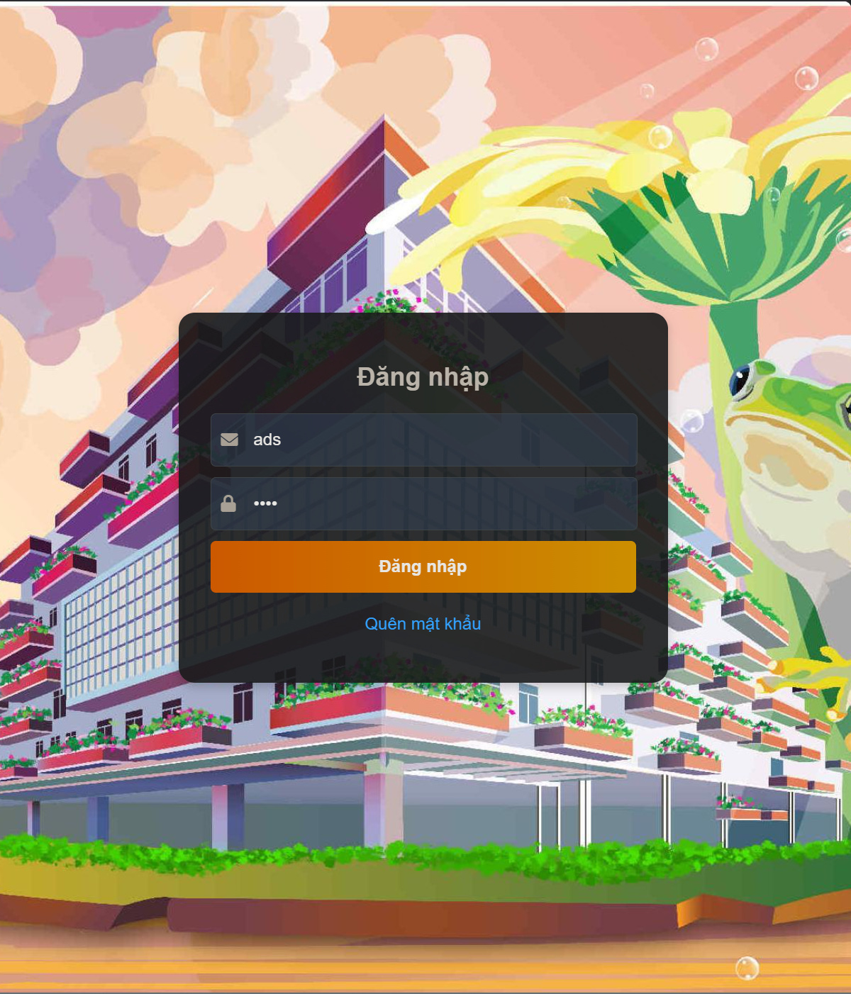

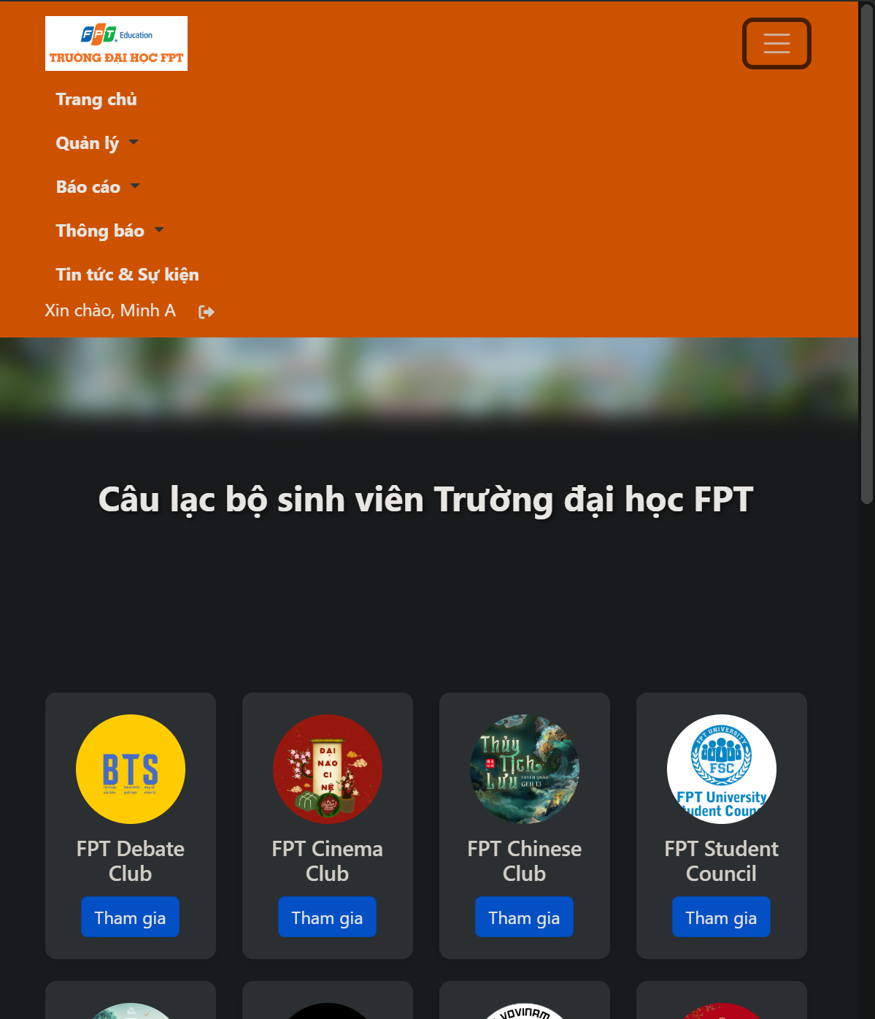

2 Đánh giá hoạt động

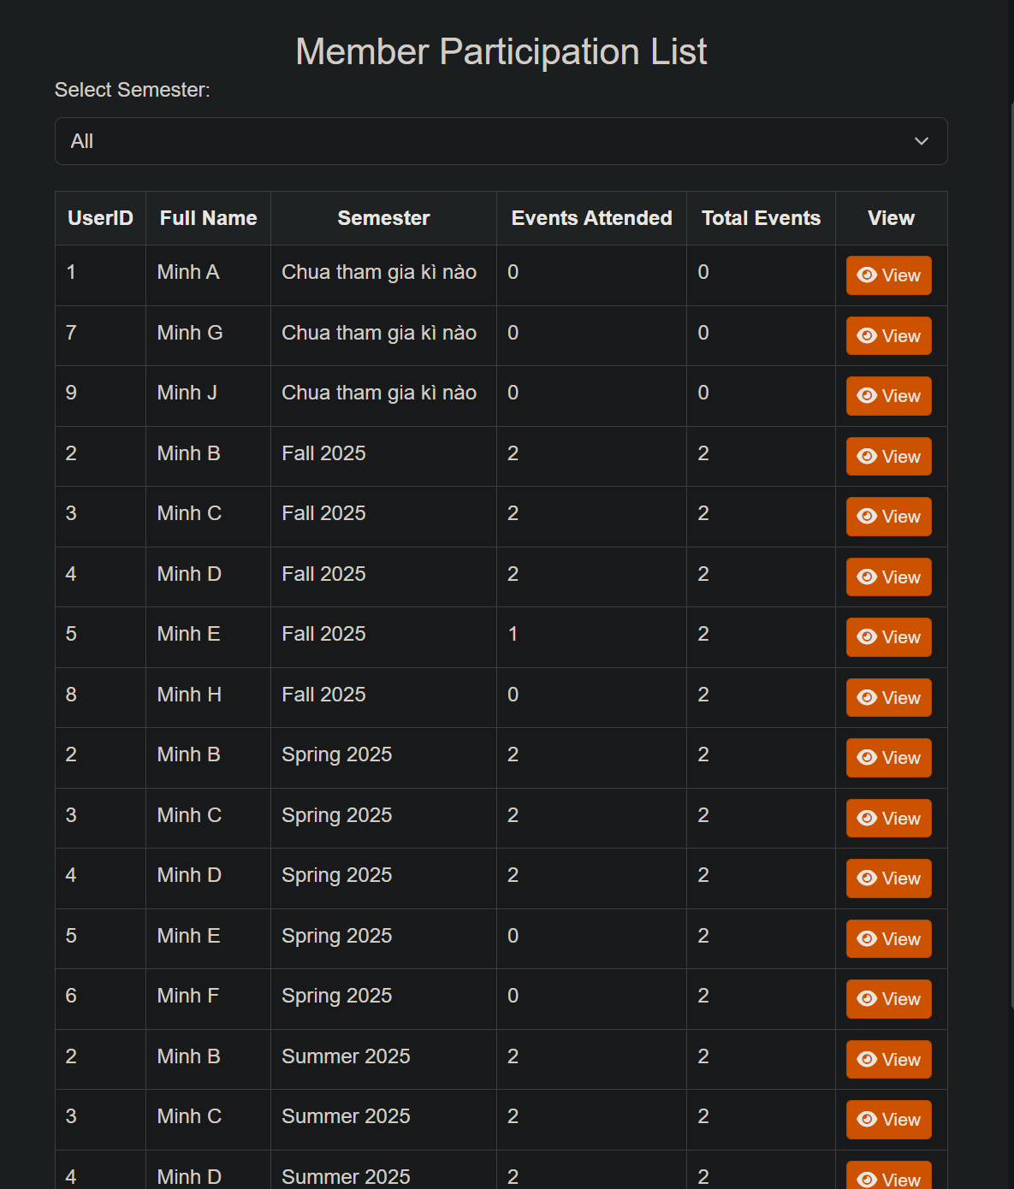

** Filter them kì học

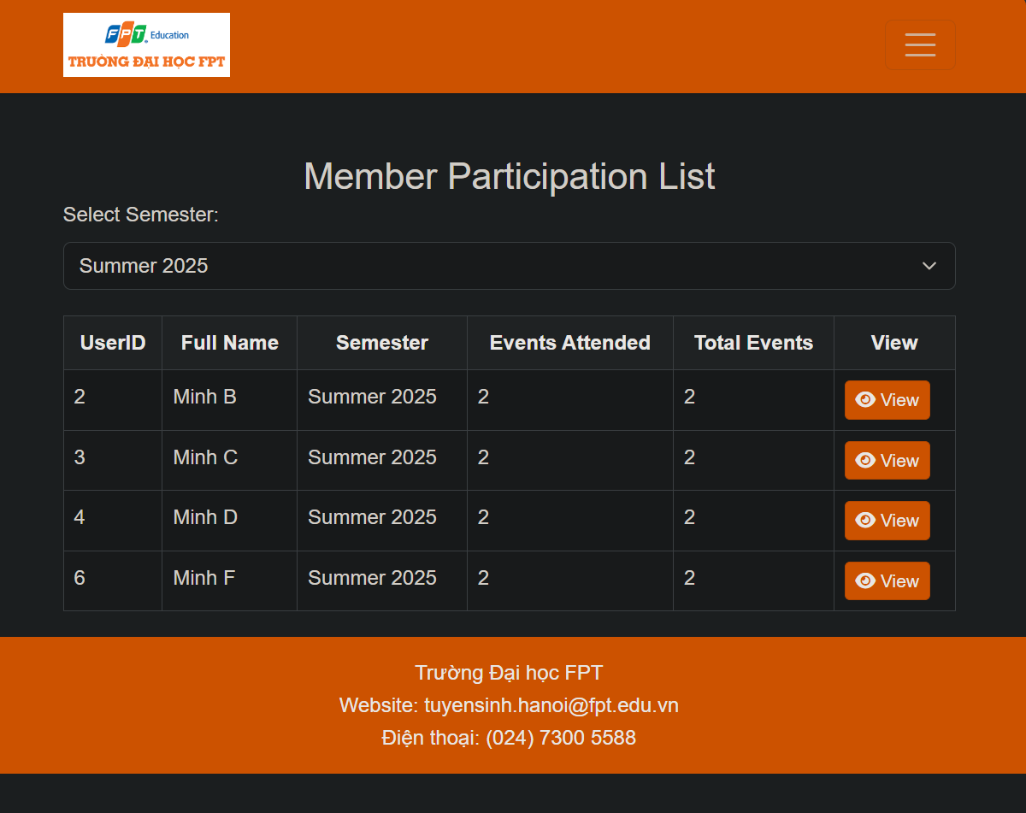

**Xem được participationlevel

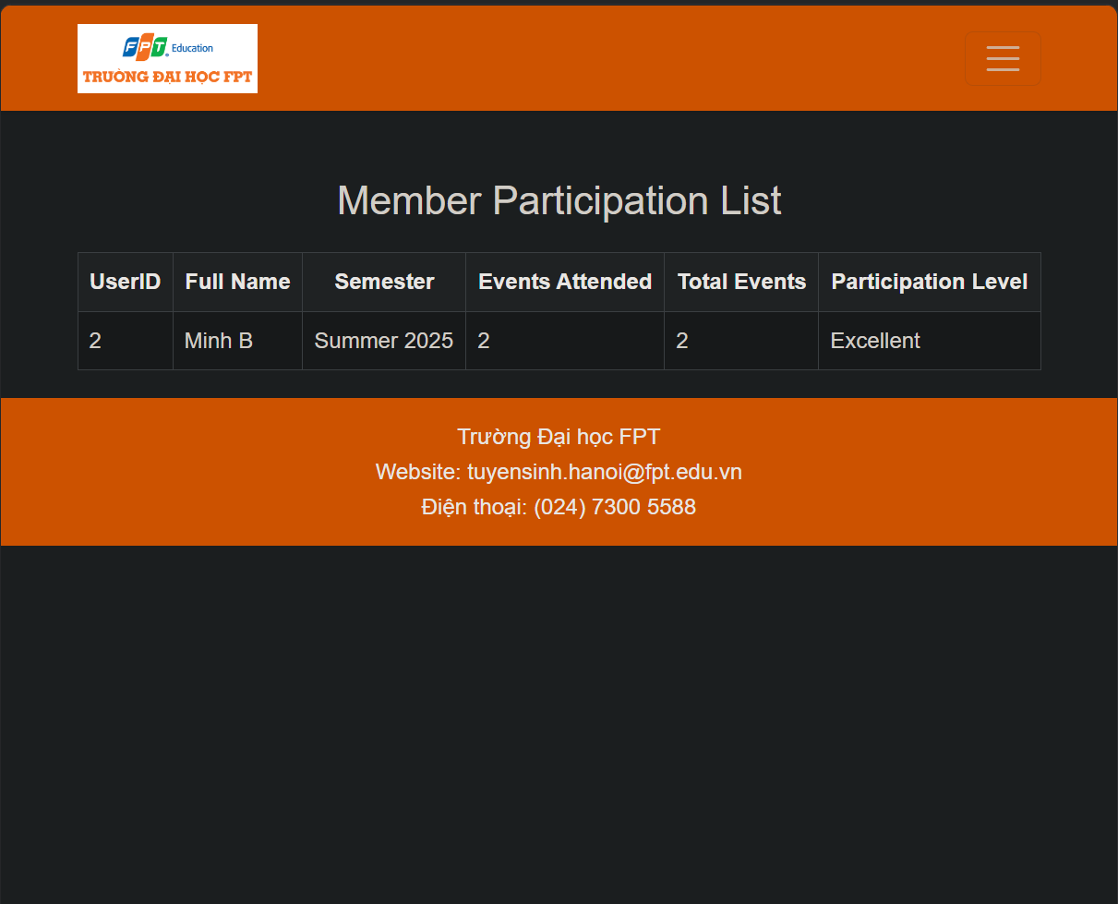

3 Báo cáo và thống kê

3.1 Chairman, Admin, Vicechairman, Member

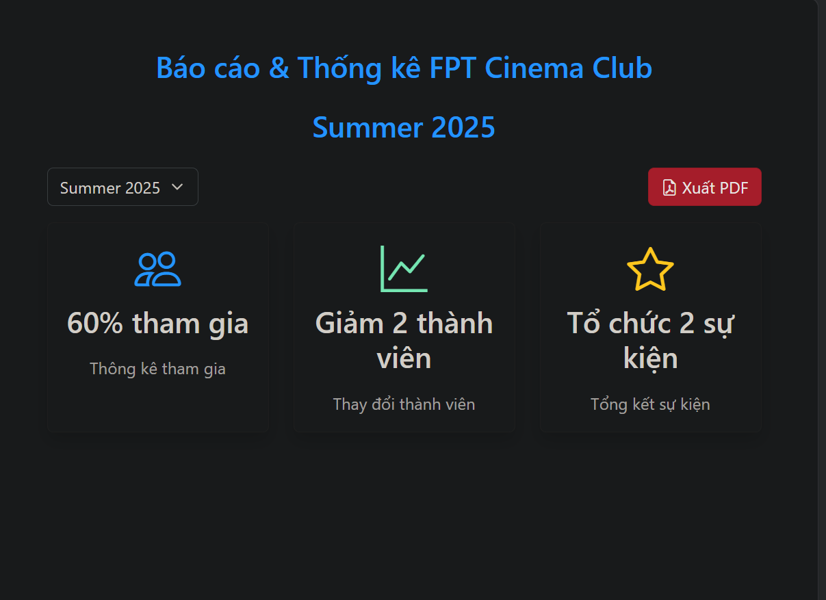

3.2 Filter theo semester

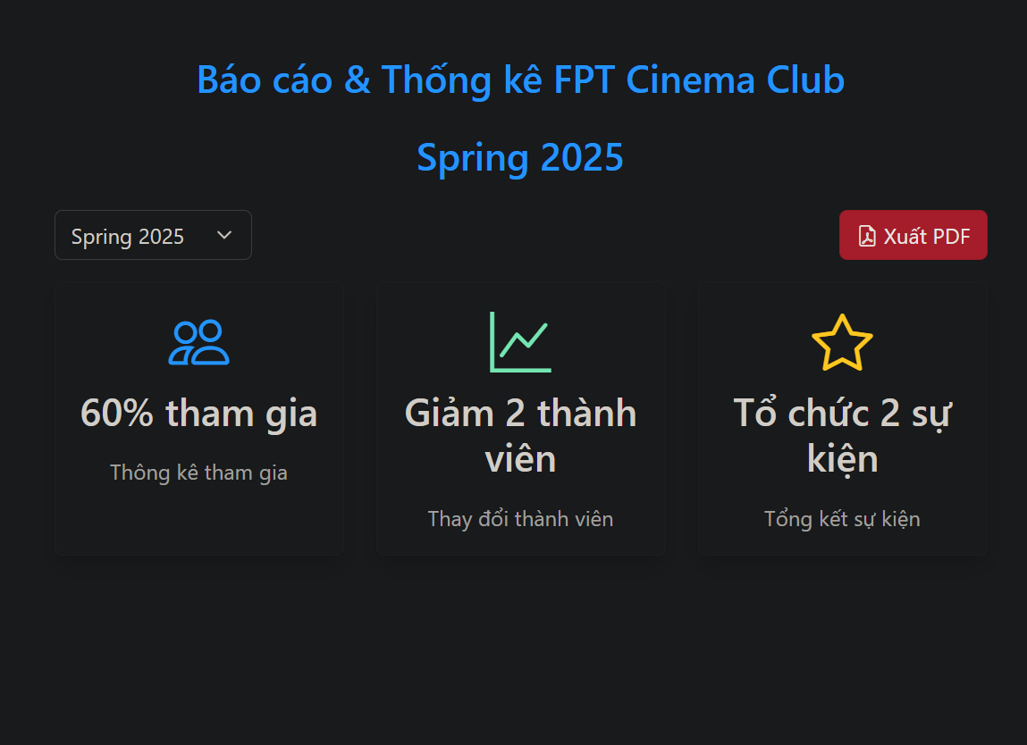

3.2Leader

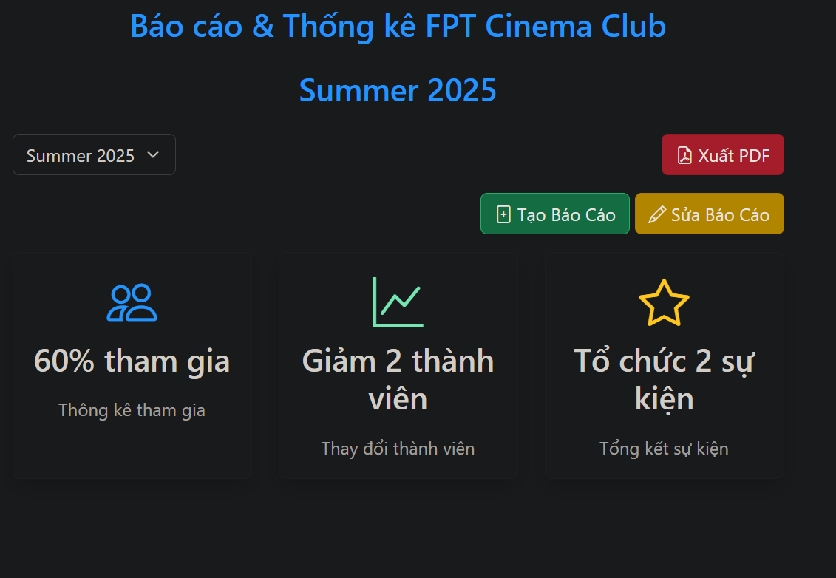

Sửa Báo cáo

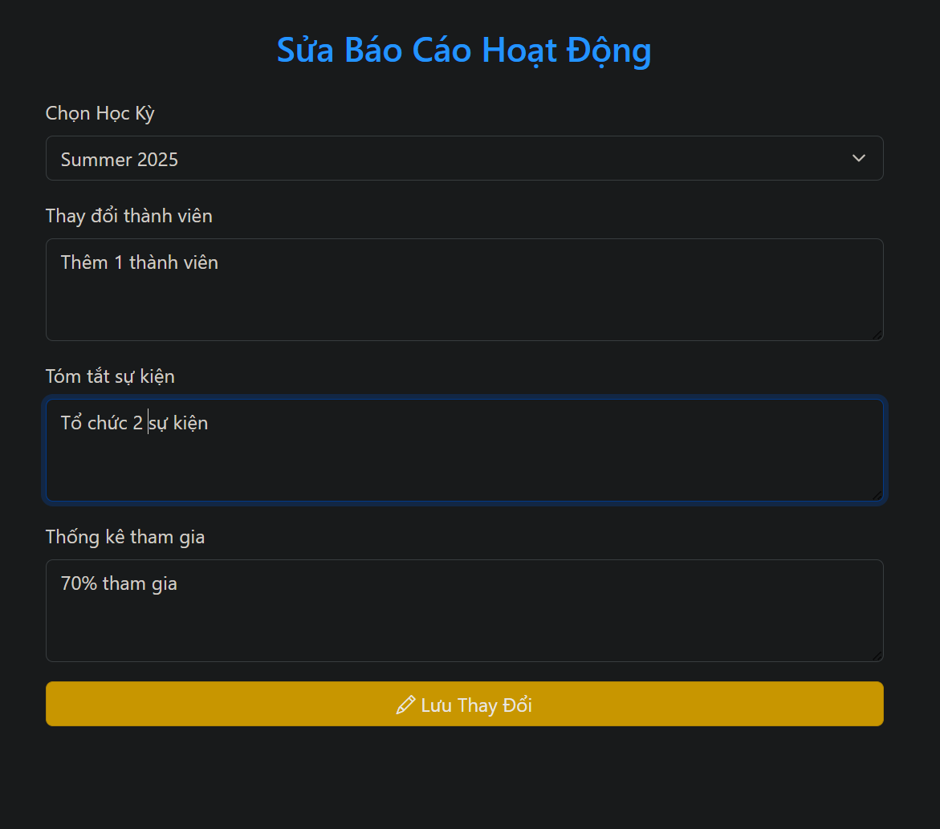

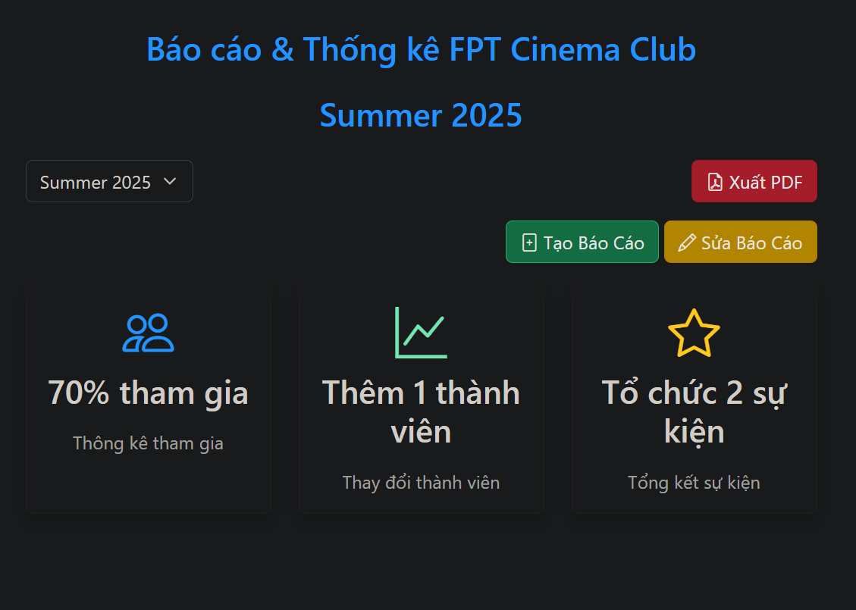

Thêm báo cáo

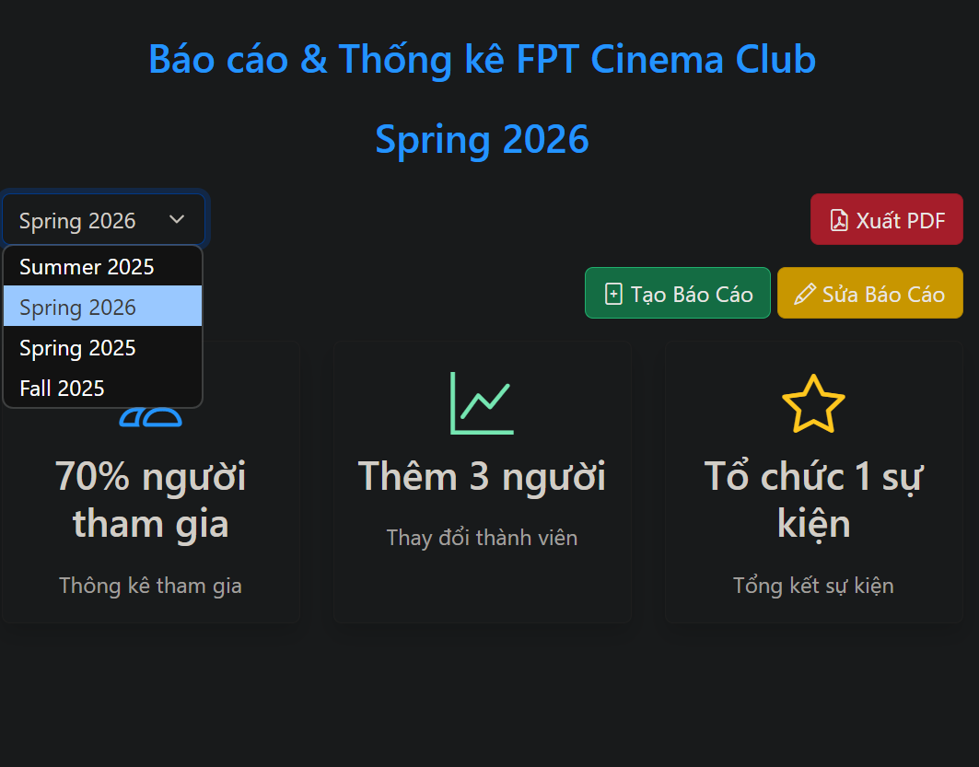

4 Thông báo club

4.1 TeamLeader, Member

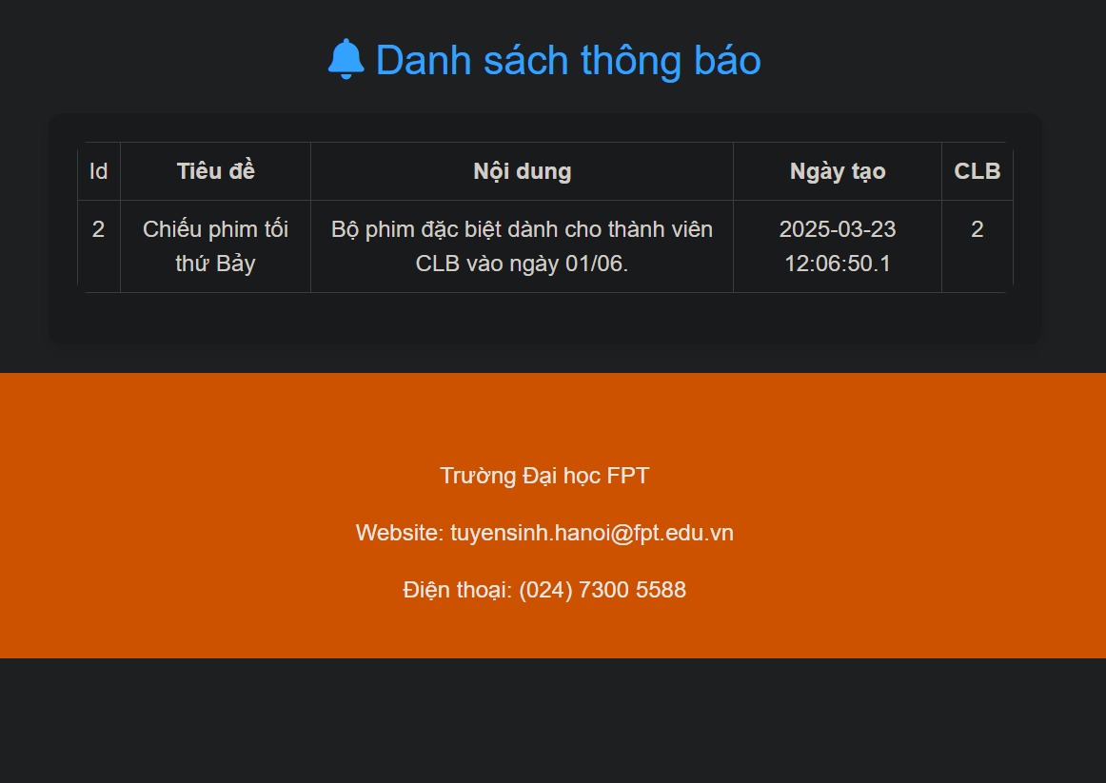

4.2 Chairman/ViceChairman

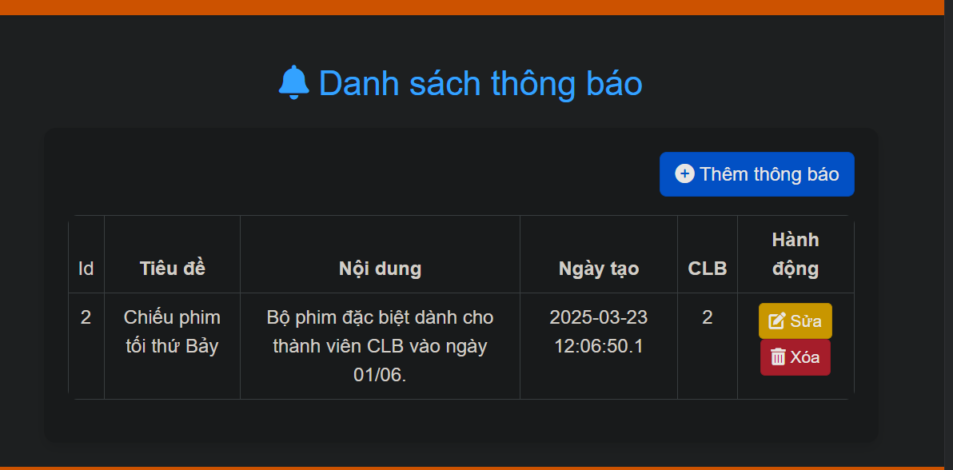

Them thông báo

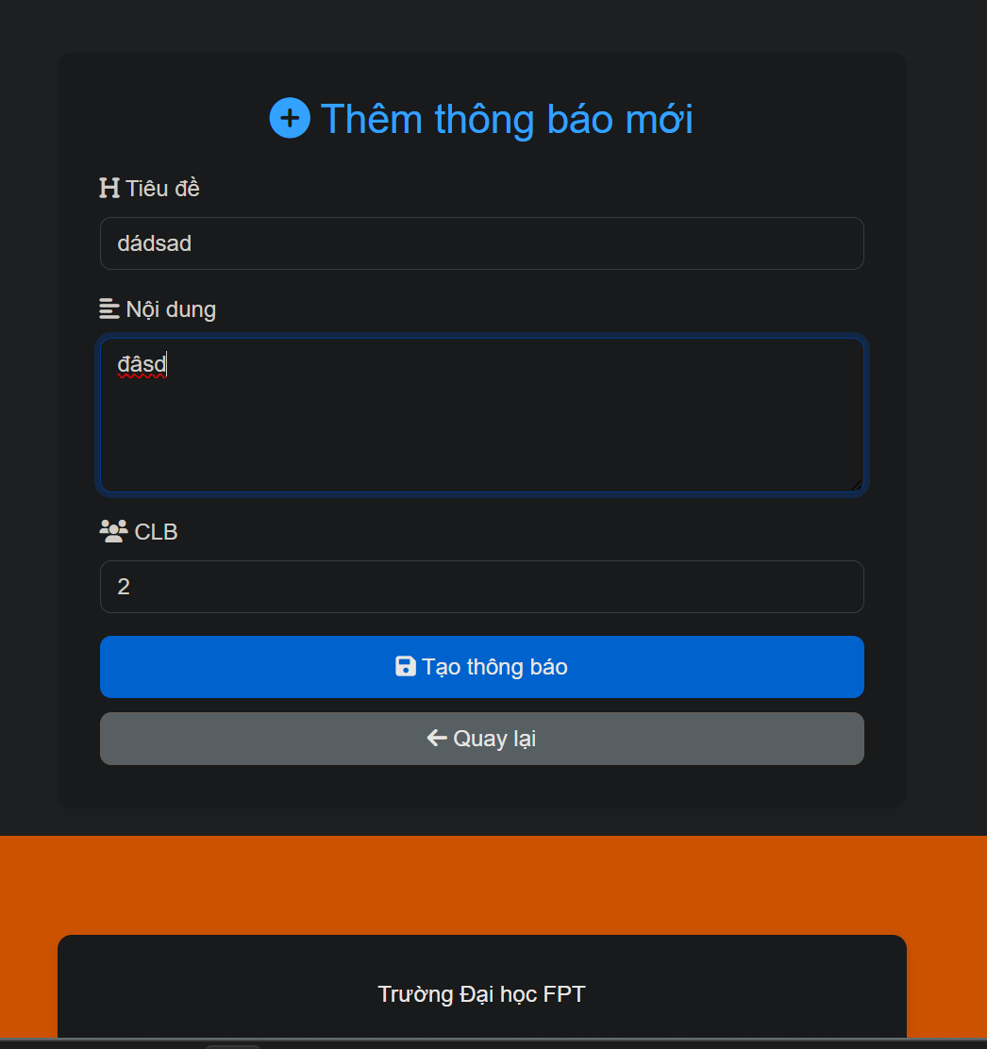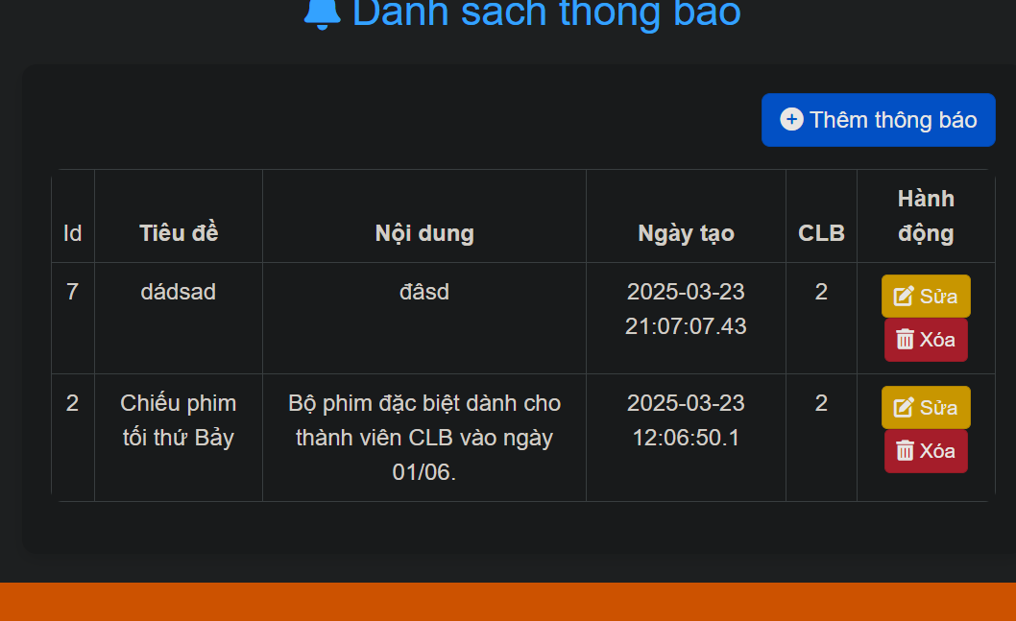

Sửa thông báo

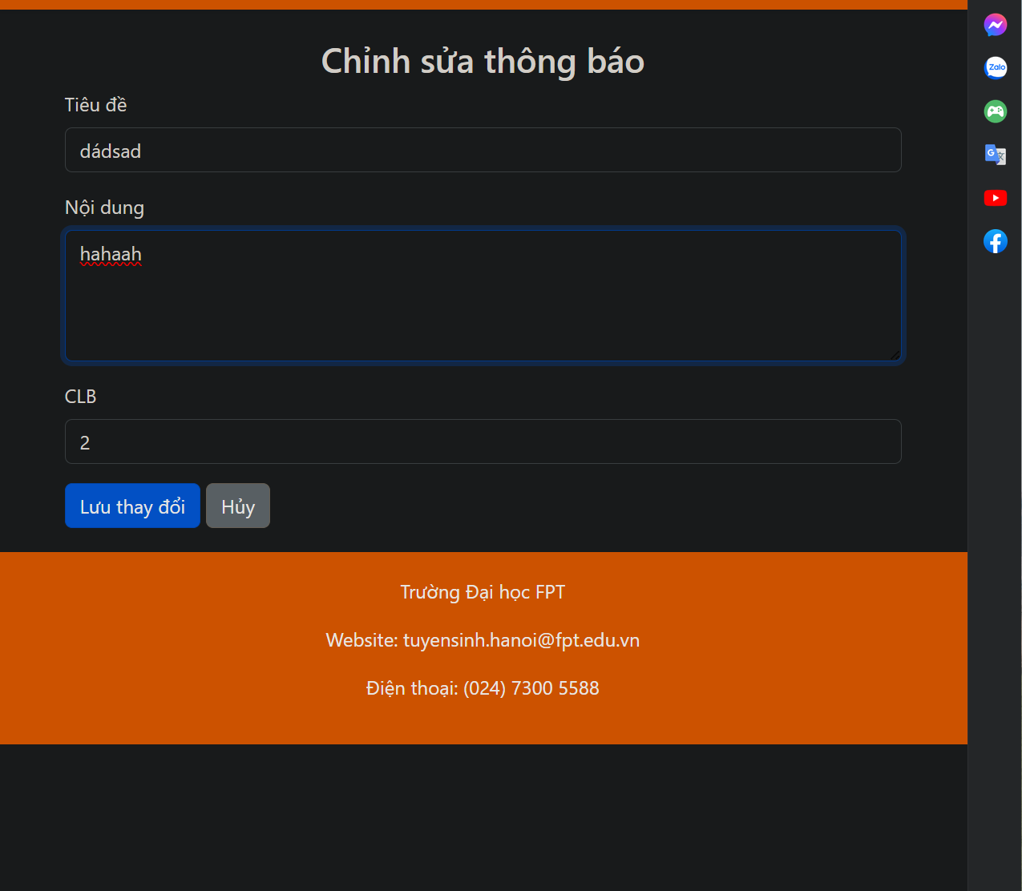

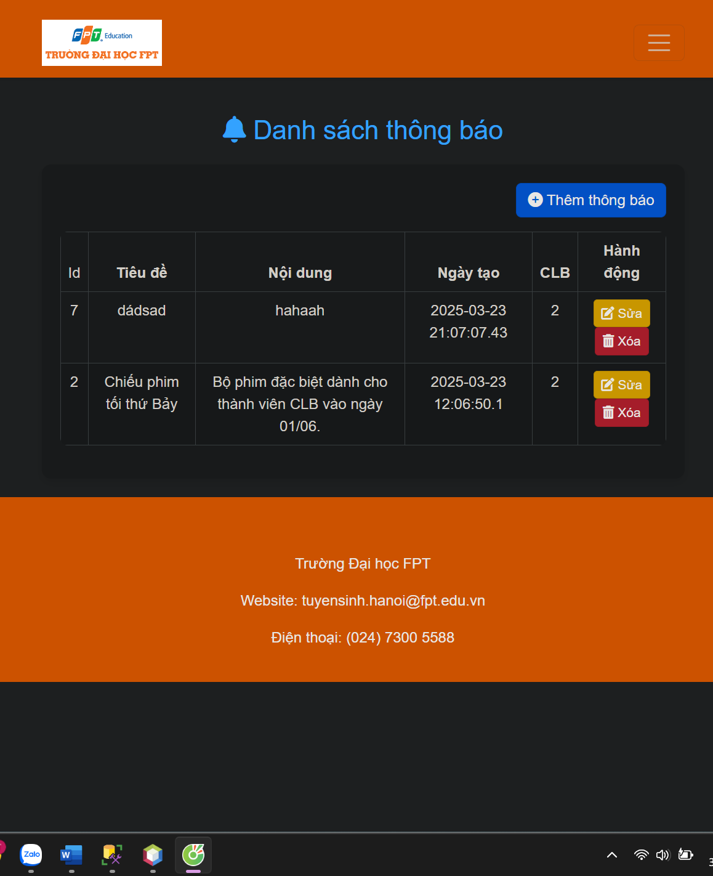

Xóa thông báo

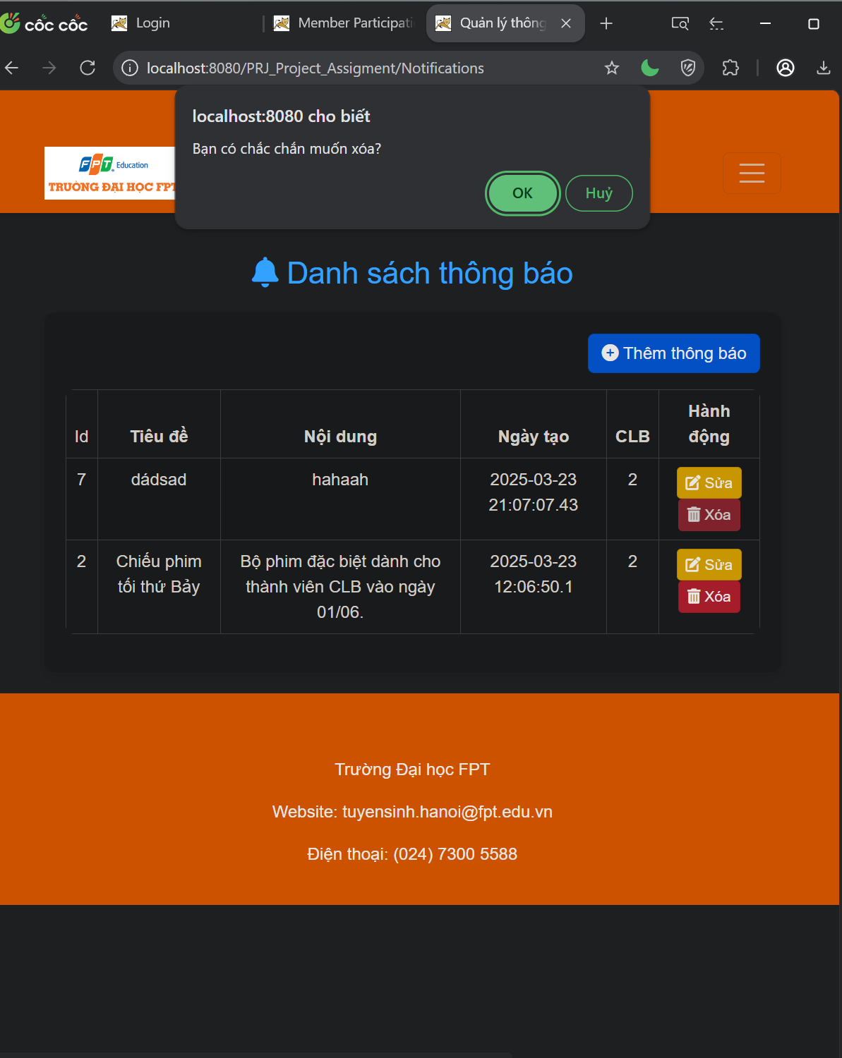

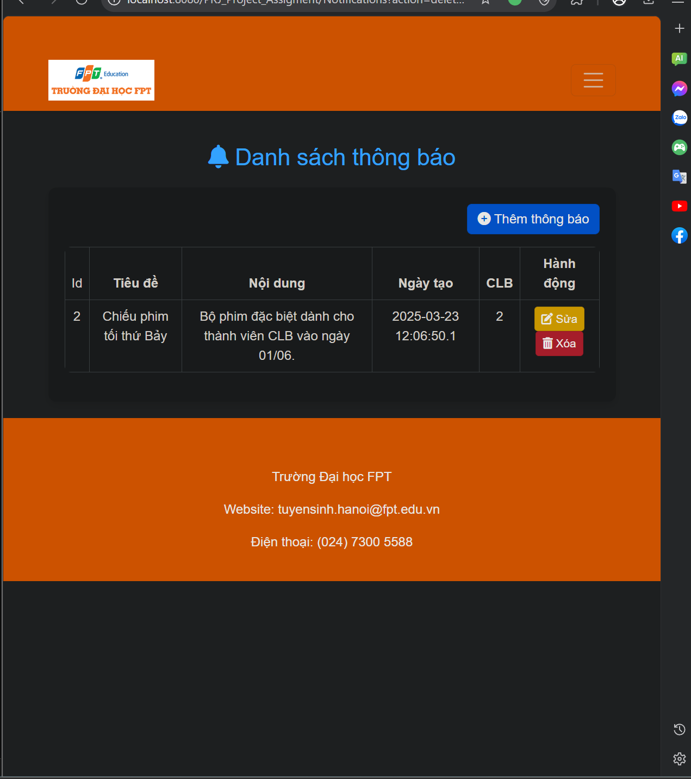

5 Phê duyệt

5.1 Chairman/Vicechairman

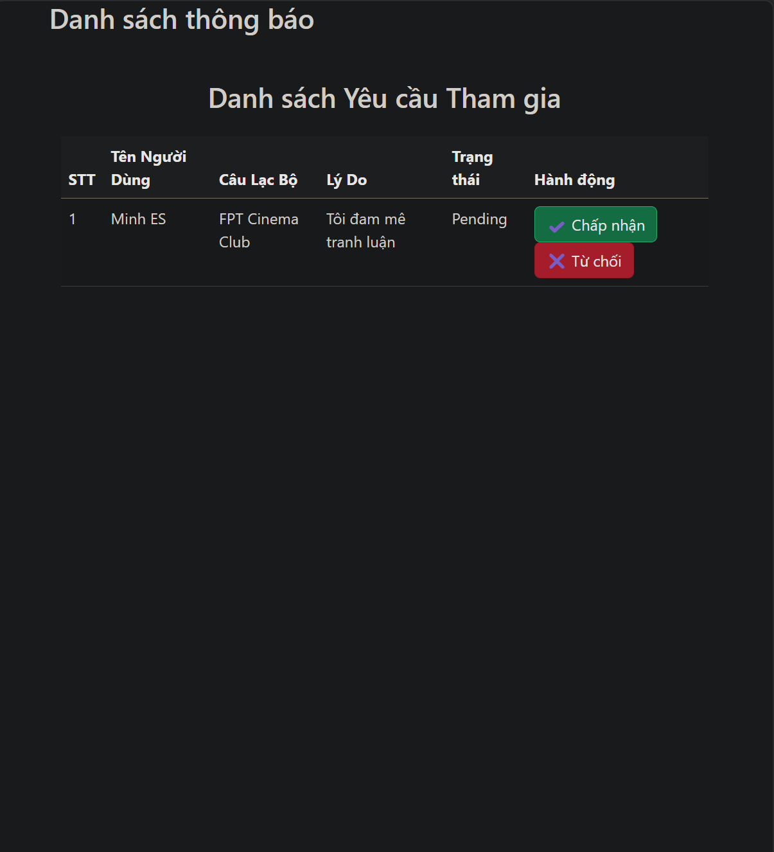

Chấp nhận

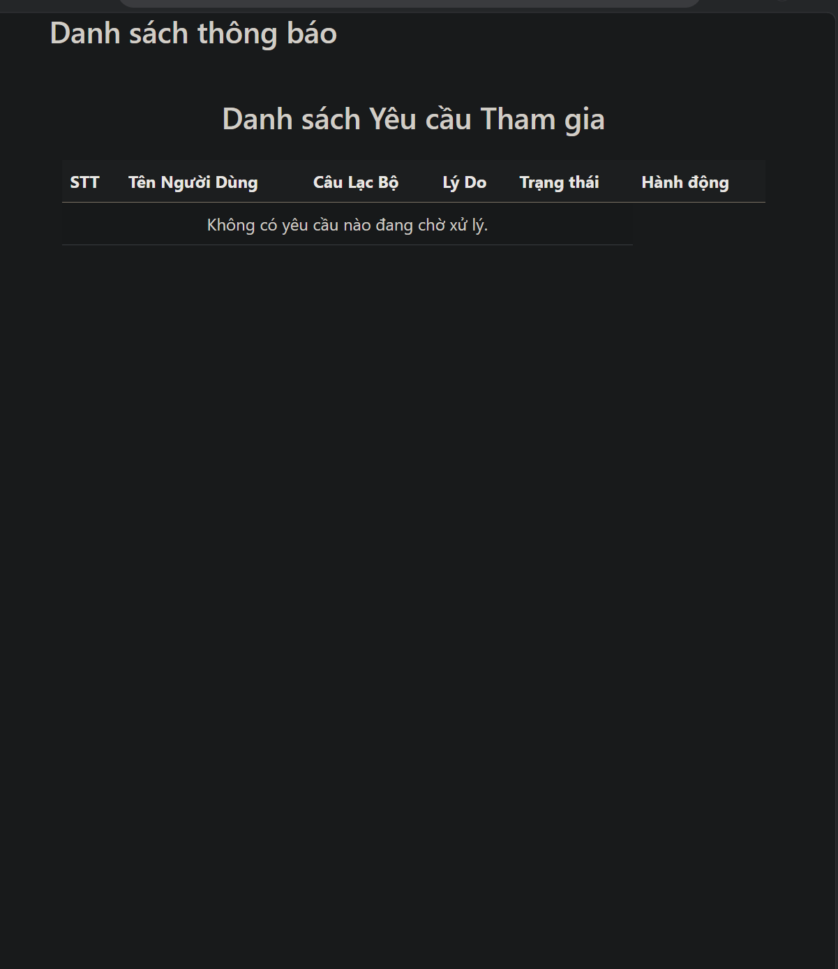

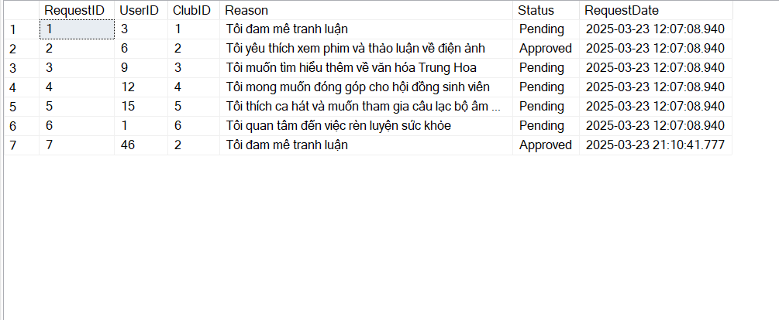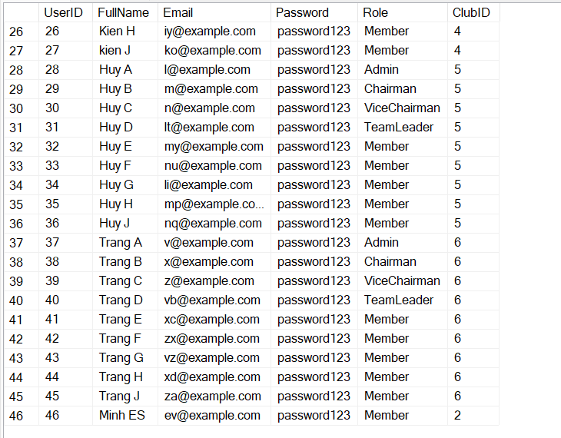

5.2 member

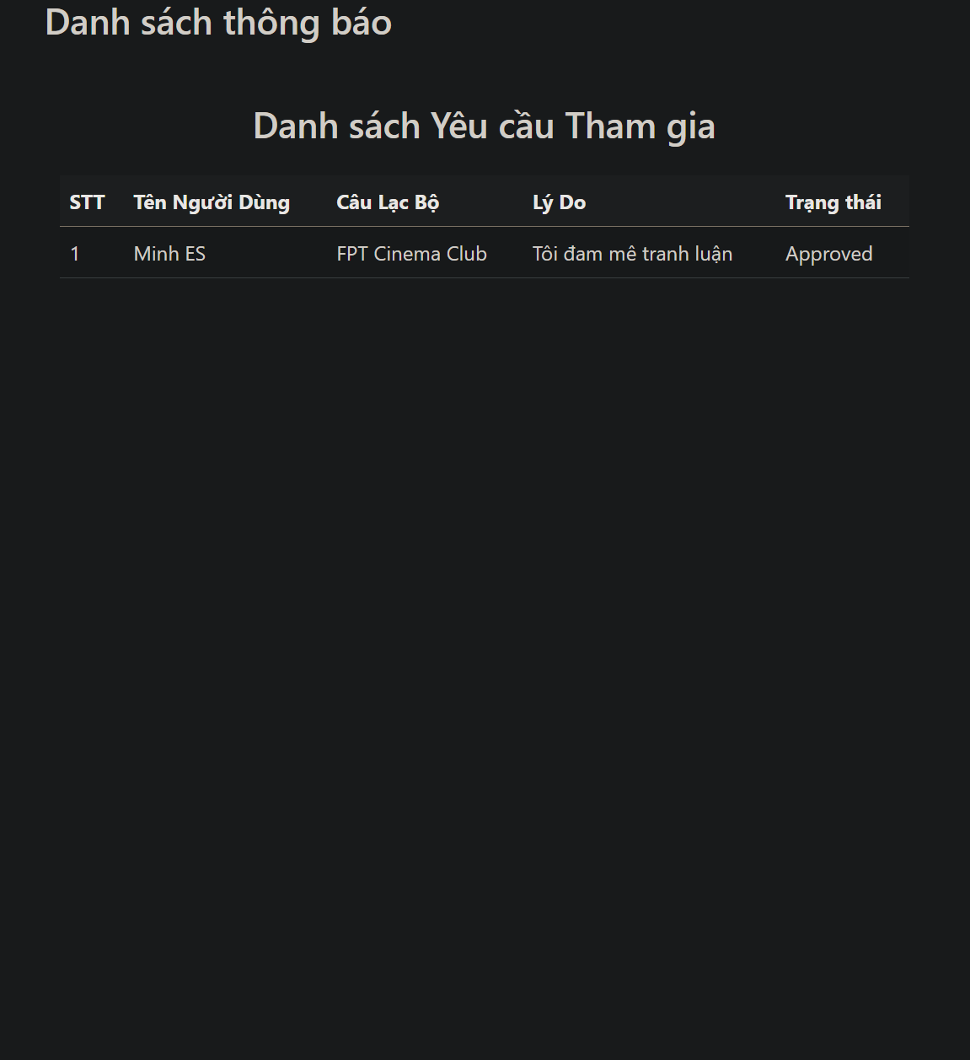

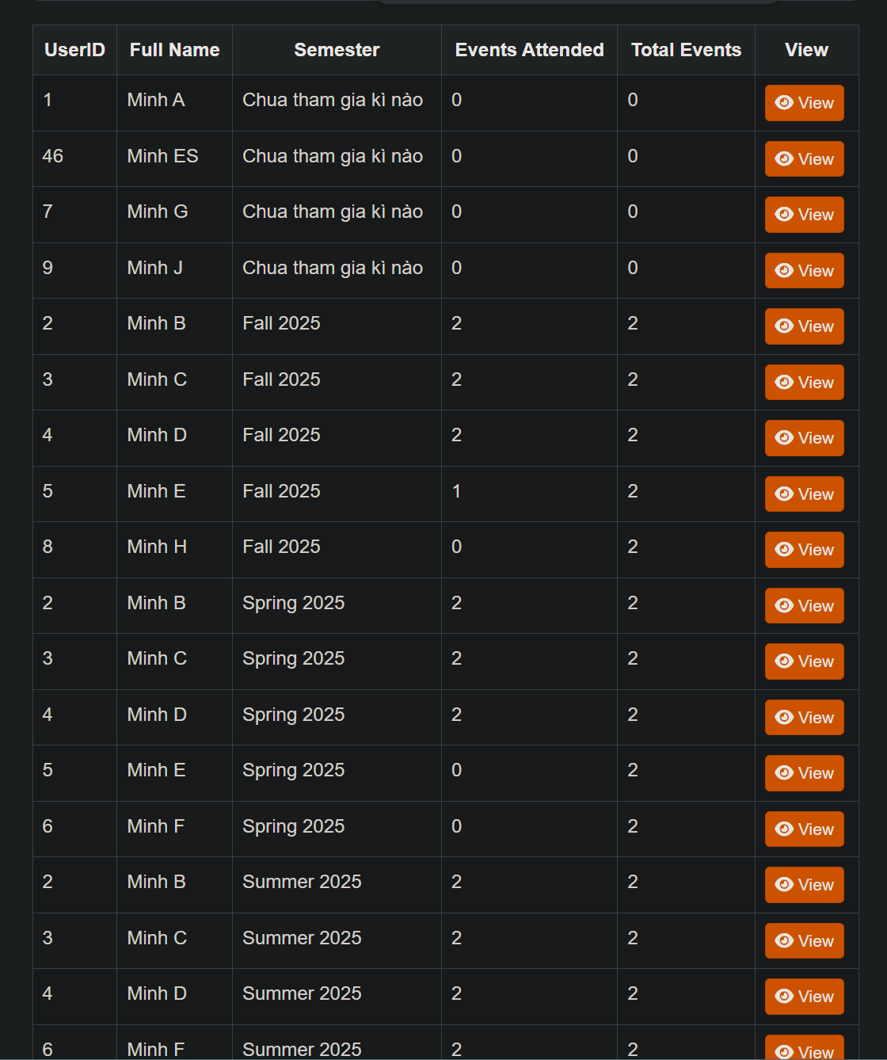

# IV. Appendix

## 1. Assumptions & Dependencies

AS-1: The system will be used within the organization's internal network.

DE-1: Users have basic knowledge of using Windows applications.

## 2. Limitations & Exclusions

L-E : The system will not support mobile platforms in the current version..

## 3. Business Rules

## 

BR- 1: Default admin account: MemberID is “Admin” and password is “@admin123”.

BR- 2: Default staff account: MemberID is “Staff” and password is “@staff123”.